**VAIDYA: HEALTH CARE CHATBOT**

**Rhythm Goel , Ratnesh Puri Goswami , Somesh Totlani , Parv Arora , Rahul Bansal and**

**Dinesh Vij* , Gurjeet Singh Sodhi+**

**\*Project Supervisor**

**+Project Coordinator**

**Department of Computer Science Engineering**

**Apex Institute of Technology**

**Chandigarh University , Mohali , Punjab**

**Email :** [**19BCS6094@cuchd.in**](mailto:19BCS6094@cuchd.in)**,** [**19BCS6082@cuchd.in**](mailto:19BCS6082@cuchd.in)**,** [**19BCS6085@cuchd.in**](mailto:19BCS6085@cuchd.in)**,** [**19BCS6088@cuchd.in**](mailto:19BCS6088@cuchd.in)**,** [**19BCS6087@cuchd.in**](mailto:19BCS6087@cuchd.in)**, and** [**dinesh.e10419@cumail.in\***](mailto:dinesh.e10419@cumail.in*)**, projects.ait**[**@cumail.in**](mailto:dean.research@cumail.in)**+**

***Abstract*—** **Health care is very significant for you to live a well and healthy life. Often people do not know all the treatments or symptoms associated with a particular disease. For young people, users with the problem go to the hospital in person for a laborious test and it is very problematic to get a doctor's appointment for any health problems, and managing phone calls. These types of problems can be solved by using Healthcare/Medicinal Chatbot by providing appropriate guidance regarding healthy living. The notion is to create a medical chatbot using Neural Networks that can provide with the info and diagnose the disease and deliver basic information about the disease and when and where to consult a doctor. The effectiveness of medical chatbots rest on Natural language processing technique that helps users post their concerns about any disease and also their health. The user can ask any private question related to health care via chatbot without being actually present at the clinic or hospital. This will help reduce the cost of health care and improve access to medical information through medical chat-bot. The program development plan is to analyze customer feelings.**

# **INTRODUCTION**

## **A. PROBLEM DEFINITION**

Nowadays, health care is vital for our life. In today’s world, people are busy with their work receptions, workplace works, and additional addiction to the web. They are not very engaged regarding their health. Therefore, they evade going to a doctor for a slight problematic situation that may become a major disease in the future. Creating query response forums is becoming an calm way to reply those inquiries instead of browsing through a list of relevant documents from online. The core determination of this scheme is to remove the linguistic gap between the user and health providers by giving instantaneous replies to the enquiries asked by the user. Several of the current systems have some limitations like as there is no prompt response delivered to the patients, they have to wait for expert’s acknowledgment for a delayed time frame. Some of the procedures may charge an sum total to execute live chat or communiqué with doctors online.

***B. PROBLEM OVERVIEW***

Therefore, we have decided to improve the system to establish human-computer communiqué through natural language processing (NLP) technique. As chatbot is a structure that can connect with users in the innate linguistic. There are three scrutinizes that understand the natural language, namely, to identify the main linguistic relationships that have been completed in order to divide the topic into a sentence. Then an explanation of the queries and texts is done. Also, Semantic translation uses word information which means the massive quantity of information is accessible online which allows chatbots to deliver precise and active information based on user needs. Chatbot is a business that mimics personal conversation in its own accepted form as well as text or voice language with strategies such as Natural Language Processing (NLP). This program aims to matching personal conversation. Chatbot app development can be done by creating a visual interface to send input and get feedback. It is a program that works with the user by keeping track of the interaction status and remembering the previous instructions to provide functionality. “Nowadays Chatbots are being used in domains like Customer Support, Virtual Assistance, Online Trainings, and Online Reservations, and also for general conversations. The proposed Medical Chatbot can interact with the users, giving them a realistic experience of chatting with a Medical Professional. Our Chatbot can detect human message patterns using AIML (Artificial Intelligence Mark-up Language) which is a mark-up language based on XML to build AI applications. Based upon the users input it retrieves keywords from initial messages to know possible medical problems that every user has. There are few Medical Chatbots that already exist, but they do not provide users with medication for any illness but connect them with a Medical QA Forum and show them similar questions to their symptoms that doctors may have previously answered.” [1] Subsequently such data are not currently available for the system, we are trying to propose a database of common medical conditions and a typical system to offer immediate aid to patients. In addition to the planned prototypical, this database can also be used for other chatbot models. Our aim is to show that the proposed Medicinal Chatbot can be a healthier alternative than most Chatbots which are already there in the medical field.

# **LITERATURE REVIEW**

Literature review plays a vital role in getting the idea of artificial intelligence domain and application of the working system. In the past few years various medicinal chatbot designs has been proposed to provide the user with prognosis and medication sanction after detection of the sickness info from the user communications.

Another method of training and modeling chatbot is by training chat-bot by using the chatterbot library and train the bot to identify specific types of keywords to determine the user's intent. The evidence of intent will then be transferred to the backend. A bot can be trained to perform rational thinking and replies without referring to the past. The proposed approach to program development involves the use of health care. It describes in detail the business features of the planned system. Firstly, a chatbot has been created that can help users find the symptoms of their illnesses. The programmable bot helps to keep records back users responsible for using the processed input from the chatbot and converted it into action performed on the website.

“Chat-bots will be used extensively to provide communication between a person and a machine. Admin feeds certain information to the machine so that the machine can identify the sentences and decide on its own in response to the question. The chat used is actually an Indonesian chat pattern and the site used in the MySQL project. It can be missed in explaining the sentence and how to respond to it while linking the chat app to the website. So, information representation and SQL implementation in the pattern matching function is required. Model data based on chat pattern will be evaluated with the help of a series of scenarios. Chat with chat-bots will be interrupted and returned to the basic pattern. It is designed to be able to add certain information to a website as it has never been exhibited before. In the event that the submission sentences on the website are not the same, they will be resized.” [5]

“AI (artificial intelligence) to forecast the illness based on the symptoms and give the list of accessible treatments for that particular disease. It can facilitate us to figure out the problem and to address the solution.”[6]

“There are many chatbots that provide health-related services. However, the difficulty with these chatbots is that they answer only the most common health care questions. Which means that, unlike doctors, these programs cannot provide natural communication with the user. Work is being done to enable chatbots to communicate in a similar way to what happens between two people. That is, the user should get the feeling of chatting with someone rather than the bot. As a result, the chatbot becomes a visible friend of the communication user.” [9]

NLU, NLP, and ML can be utilised to produce this form of smart communication (which is commonly employed in healthcare counselling). The smart chatbots' functionalities are available in a variety of fields. The persistence of this paper is to provide an impression of the chatbot system for the healthcare industry. It also outlines the various NLU, NLG, and ML algorithms to be used in the chatbot, as well as a comparison of them.

“A chatbot using LSTM-based multi-layer embedding for elderly care” [8] paper states “We collected MHMC chitchat database for daily interviews with adults to perform this investigation. Because users are allowed to say whatever they want in the system, the pre-processing step converts collected sentences into patterns to suit a variety of conversational words. When talking to adults, the LSTM multi-layer embedding model is used to extract semantic information between words and sentences in a single turn with multiple sentences. Finally, the Euclidean grade is used to select the right question pattern, and then used to select the correct answer for the elderly. A five-fold verification method was used to train and evaluate performance. The proposed strategy worked much better than the old Okapi model with a top 1 selection accuracy of 79.96 percent, depending on the results.” [8]

# **PROPOSED SYSTEM**

## FUNCTIONALITY OF SYSTEM:

The program focuses on the messages a user gives while starting a discussion. The notion of ​​this system is to identify the initial indications and symptoms, i.e., the problems that the user might be undergoing. Subsequently Chatbot has collected sufficient recognized keywords from the original messages, now begin to lead the conversation by asking questions to the user and try to make a short list of a scarce ailments that the user may suffer from. Also, Chatbot has listed the diseases that a patient might have, it now gives us a rating of the diseases that a user may have. When a list of potential diseases occurs, Chatbot starts asking the user how he or she is feeling. Once it has acquired a sufficient amount of data it detects a disease that the user is most likely to suffer from. After Chatbot diagnoses a user's condition, it measures the severity of the disease and acts appropriately by recommending herbal remedies to the user or by referring the user to a physician if the dose reaches a predetermined dose.

# **DATA PREPARATION**

## SOURCES AND OBSERVATIONS

In the process of creating the data Ref. Fig [1], we used WebMD.com to obtain reliable health information to generate statistics. For complete drug information, Drugs.com was used. Also, we also decided to consult with a medical professional to gain an in-depth understanding of those common symptoms, whether related to headaches, stomach aches, skin problems, or intestinal pain, to better understand the background of recurrent patients. Experts also look at how to differentiate between colds and coughs, diarrhea and laxity, and more.

## QUALITY AND FILTERING

Updated chatbot data is updated to ensure system efficiency. Many diseases have similar symptoms that must be carefully monitored. Each symbol is related to a specific terminology and mutual linguistic. It is vital that large groups of categories were created initially to cover a wide range of diseases and to reduce them according to specific symptoms, which are easy to diagnose. Because a patient's description of the symptoms is usually incorrect, it may lead to a wrong diagnosis. As a result, in order to evaluate a proper diagnosis, the system should come back with a series of simple questions that need to be answered.

Obviously, a system is very useful for shared or elusive difficulties that may arise and may involve recurrent access to the structure, serious or long-lasting complications may exist in such a user environment, and it is important with websites like www.webmd.com and [www.drugs.com](http://www.drugs.com) to manage a system to monitor these situations and ask the patient to see a specialist as soon as possible,(that’s why we took reference from such websites), and also recommended that we book an appointment using the system. These important conditions are identified by keywords such as chest tightness, diabetes, or by a survey that asks if the patient has taken any previous medications or has had symptoms for a long time.

## DATA PREPROCESSING

We first preprocessed our data to make it consistent for the categorization purpose. Lowercase conversion, stop word removal, tokenization, and stemming are all common preprocessing procedures. The text is first tokenized or split using delimiting characters such as white space or punctuations, which are non-alphanumeric letters. Stop words, such as articles, conjunctions, and prepositions, are eliminated after tokenization.

Because these terms provide no dependency or context information, deleting them allows you to concentrate on the most crucial keywords. Furthermore, all capital typescripts are converted to lower-case letter counterparts.

Lemmatization, which is the same as the stem but does not require the formation of the stem of the word, is another method of processing used. As a result, lemmatization offers the option to change the name in basic forms.

In addition to the strategies mentioned above, we are looking at Microtext Normalization because our data was intended for use on the chatbot system, and was found to recover segment precision by about 4.5%.

Words like "gud" and "2mrw" are combined into "good" and "tomorrow," respectively.

|  |  |
| --- | --- |
| How to cure fever ? | Medications such as paracetamol and ibuprofen can help relieve discomfort. Avoid giving children aspirin as this may cause an unusual, serious condition. |
| Symptoms of a burn ? | While a skin burn, pain types can be from mild or severe also, blister, peeling of skin, with total loss of colour, or redness  And also, sensitivity to pain, swelling, or tenderness |

***Fig [1]: Data Preparation***

## DATA REPRESENTATION

Two major components of our chatbot system are required.

One is to treat the patient's intentions as a multi-stage problem, and the other is to treat it as a challenge to predict sequence. Based on the embedded terms used, the classification module accepts the input statement and separates it accordingly for specific purposes. The sequence module detects the sequence of objectives and predicts the output, allowing the conversation to continue. We need different sentences that convey the same objectives of the separating function. The next arrangement prediction module will question the patient queries to confirm the patient's difficulties and symptoms.

These goals can be separated into two categories, one for semantics and one for health care. The latter needs more attention because access to this information is less systematic, and the first one has a predictable framework.

Following Fig [2] shows example and glimpse of how bot works and communicates with end user and replies to query asked accordingly as per training and database for the query:

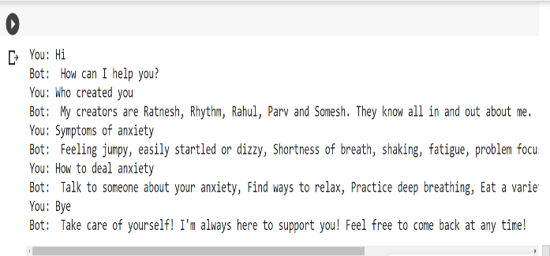

***Fig [2]: Sample Conversation After Data Preparation***

# **SYSTEM ARCHITECTURE**

The heart of chatbot development is chatbot architecture. The architecture involved in designing a chatbot differs drastically depending on the usability and context of commercial processes. So, depending on the needs of the customer, we may need to change some pieces, but the essential communication flow remains the same.

The architecture to choose relies on the type of domain the chatbot will be in. For example, you might ask a chatbot a question, and the chatbot will respond. Perhaps you leave a conversation in the middle, only to resume it later. Depending on the type of chatbot you design, the conversation history may or may not be saved. A pattern matching architecture would be ideal for narrow domains. Chatbots that engage with numerous domains or services, on the other hand, should use a broader domain. In these circumstances, advanced, cutting-edge neural network architectures like Long Short-Term Memory and reinforcement learning agents are employed.

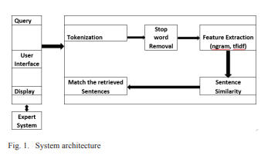

***Fig [3]: System Architecture***

The system architecture of the chatbot healthcare application is depicted in the diagram above Ref. Fig [3]. The customer types the queries into the user interface as text. The user query is accepted by the User Interface, and then forwarded to the chatbot editor. Processes for pre-processing text experience in a chatbot app include making tokens, where words are made tokens, suspended words are deleted. To find out, answers to questions are stored on the information website.

For better processing, texts or sentences were separated word by word. Also, when combined with one of the characters shown, it separates text into words. Redundant punctuation marks are removed and words are divided. The following steps are suggested by this.

For improved analysis, words or sentences were parted from word for word. When combined with the characters shown, it divides the text into words. Punctuation is detached and disputes are disconnected from sentences. The following steps are suggested by this. In an attempt to extract keywords, stop words are removed from phrases. It is often used to remove unnecessary items, such as words that appear recurrently in sentences. It is also used to remove words such as, a, and those that are not important or that have no special significance. This section is used to abbreviate dispensation time or to reduce computational complexity issues.

Answers to the question are retrieved and displayed on the user interface as a result of the above process. Here the application is designed to provide short-term feedback. It removes the burden on the feedback provider by directly delivering feedback to the user using the expert system. The project is designed for the user to save the user's time when consulting a doctor or specialist to find a health solution.

Following flowchart depicts working in the architecture:

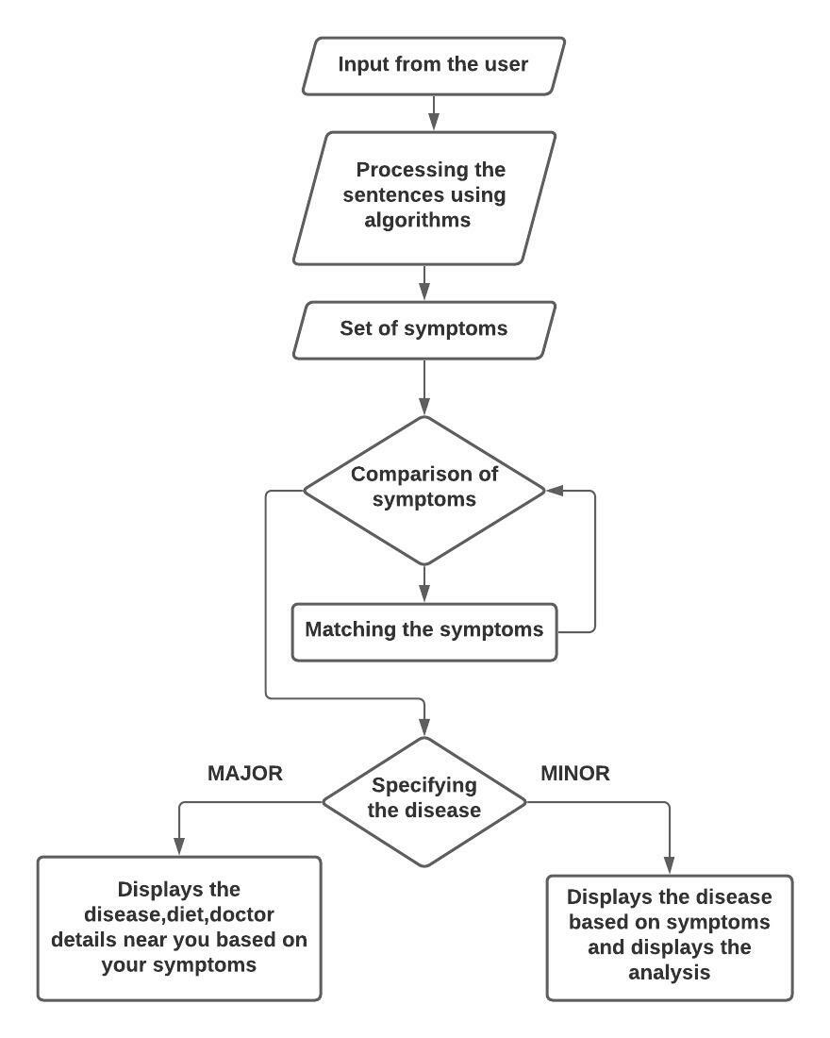

***Fig [4]: Flowchart of Model’s working***

# **Result and analysis**

To create a more efficient and user-friendly GUI for our health chat, we used the TKINTER module for Python, the Tkinter usually comes with Python integration, uses Tk and is a standard Python Guided User Interface framework. It is famous for its easiness and user-friendly interface. It is an free, open-source and existing under a Python license.

Following Fig [6] shows UI Home Screen of Healthcare Chatbot Application.

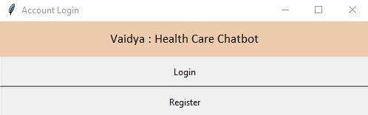

***Fig [5]: Home Screen***

The application consists of Register and login page:

REGISTER:

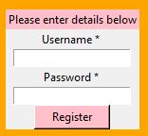

***Fig [6]: Register Screen***

If user is new, he/she needs to enter details to register Ref. Fig [6] and after registration he/she is directed to login window Ref. Fig [7] on successful login, user is directed to window where he/she can start a conversation with the BOT.

LOGIN:

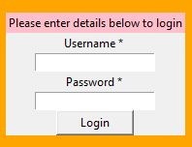

***Fig [7]: Login Screen***

Output Screen depicting conversation between end user and BOT Ref. Fig [8]

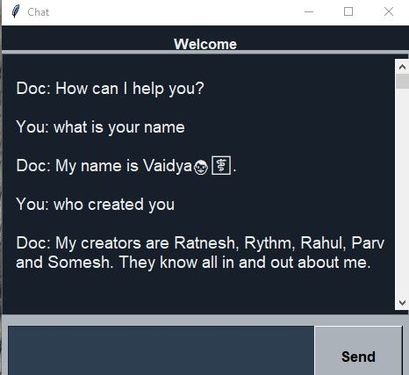

***Fig [9]: Output Screen when user gives the input query***

# **FUTURE SCOPE and CONCLUSION**

Medicinal data is very important and should not be revealed to anyone. No unauthorized person or anyone should have admittance to the user's medicinal statistics. Thus, we can add a security system for the Healthcare Chatbot to secure authentication process. If somebody entrees a website without user information, only encoded data should be exhibited. To alleviate the trouble of texting, the notion of voice-based chatbot system can also be upgraded so that everyone can ask their question and find a solution on the chatbot. In future, in order to upgrade our chatbot system, we may also attempt to use facial recognition feature to serve as a patient counselor. Providing patients, a place to load their medical records is also an added feature. We also resolve to incorporate multiple modal features into forthcoming system upgradation.

Healthcare Chatbot is a great chat tool to patients needing quick hassle-free assistance. Here the application is designed to provide a temporary response. It relieves the burden on the feedback provider by directly delivering feedback to the user using the expert system. This project is designed to save user time by consulting a doctor or therapist about a health solution. Thus, we have created a useful system in the medical center or clinics to aid users by spontaneously asking questions related to medicinal purpose. The system detects the drug API release and detects and displays all drug names. We use NLP because we want the system to interconnect with patients/users on their own terms. Therefore, using the SVM algorithm and the sickness indications system can envisage infections. The user can find the related response displayed, and then forward this response to the analysis. The advantage of chatbots is that they carry an invisible doctoral help and consultation that too 24/7.

# **References**:

[1] Comendador, B. E., Francisco, B. M., Medinilla, J. S., Nacion, S. M., & Serac, T. B. (2015). Pharmabot: A Pediatric Generic Medicine Consultant Chatbot.

Journal of Automation and Control Engineering, 3(2), 137-140.doi:10.12720/joace.3.2.137-140.

[2] Kazi, Hameedullah & S. Chowdhry, B & Memon, Zeesha. (2012). MedChatBot: An UMLS based Chatbot for Medical Students. International Journal of

Computer Applications. 55. 1-5. 10.5120/8844-2886.

[3] M. Jovanović, M. Baez and F. Casati, "Chatbots as Conversational Healthcare Services," in IEEE Internet Computing, vol. 25, no. 3, pp. 44-51, 1 May-June 2021, doi: 10.1109/MIC.2020.3037151.

[4] Emanuela Haller, Traian Rebedea Faculty of Automatic Control and Computers university Politehnica of Bucharest, 978-0-7695-4980-4/13 $26.00 ©️ 2013

IEEE. "Designing a Chat-bot that Simulates a Historical Figure"

[5] Imran Ahmed and Shikha Singh"AIML Based Voice Enabled Artificial Intelligent Chatterbot”, International Journal of u-and e-Service, Science and

Technology Vol.8, No.2 (2015)

[6] Bayu Setiaji, Ferry Wahyu Wibowo, Department of Informatics Engineering STMIK AMIKOM Yogyakarta, Yogyakarta, Indonesia, 2016 IEEE "Chatbot Using A Knowledge in Database-Human-to-Machine Conversation Modeling".

[7] V. Manoj Kumar"Sanative Chatbot for Health Seekers”, JECS Volume 05 Issue 3 March 2016 Page No.16022-16025.

[8] Imran Ahmed and Shikha Singh"AIML Based Voice Enabled Artificial Intelligent Chatterbot”, International Journal of u-and e-Service, Science and

Technology Vol.8, No.2 (2015).

[9] U. Bharti, D. Bajaj, H. Batra, S. Lalit, S. Lalit and A. Gangwani, "Medbot: Conversational Artificial Intelligence Powered Chatbot for Delivering Tele-Health after COVID-19," 2020 5th International Conference on Communication and Electronics Systems (ICCES), 2020, pp. 870-875, doi: 10.1109/ICCES48766.2020.9137944.

[10] T. Gentner, T. Neitzel, J. Schulze and R. Buettner, "A Systematic Literature Review of Medical Chatbot Research from a Behavior Change Perspective," 2020 IEEE 44th Annual Computers, Software, and Applications Conference (COMPSAC), 2020, pp. 735-740, doi: 10.1109/COMPSAC48688.2020.0-172.

[11] J. Gupta, V. Singh and I. Kumar, "Florence- A Health Care Chatbot," 2021 7th International Conference on Advanced Computing and Communication Systems (ICACCS), 2021, pp. 504-508, doi: 10.1109/ICACCS51430.2021.9442006.

[12] P. Srivastava and N. Singh, "Automatized Medical Chatbot (Medibot)," 2020 International Conference on Power Electronics & IoT Applications in Renewable Energy and its Control (PARC), 2020, pp. 351-354, doi: 10.1109/PARC49193.2020.236624.

[13] Hemantha Krishna Bharadwaj, Aayush Agarwal, Vinay Chamola, Naga Rajiv Lakkaniga, Vikas Hassija, Mohsen Guizani, Biplab Sikdar, "A Review on the Role of Machine Learning in Enabling IoT Based Healthcare Applications", *Access IEEE*, vol. 9, pp. 38859-38890, 2021.

[14] Zhang J, Oh Y, Lange P, Yu Z, Fukuoka Y. Artificial Intelligence Chatbot Behavior Change Model for Designing Artificial Intelligence Chatbots to Promote Physical Activity and a Healthy Diet: Viewpoint. Journal of Medical Internet Research 2020;22(9): e22845

[15] Lin J, Joseph T, Parga-Belinkie J, Mandel A, Schumacher R, Neumann K, Scalise L, Gaulton J, Christ L, Leitner K, Rosin R. Development of a practical training method for a healthcare artificial intelligence (AI) chatbot. BMJ Innovations 2021;7(2):441

[16] Bérubé C, Schachner T, Keller R, Fleisch E, v Wangenheim F, Barata F, Kowatsch T. Voice-Based Conversational Agents for the Prevention and Management of Chronic and Mental Health Conditions: Systematic Literature Review. Journal of Medical Internet Research 2021;23(3):e25933

[17] Ketan Paranjape, Michiel Schinkel, Prabath Nanayakkara, "Short Keynote Paper: Mainstreaming Personalized Healthcare–Transforming Healthcare Through New Era of Artificial Intelligence", *Biomedical and Health Informatics IEEE Journal of*, vol. 24, no. 7, pp. 1860-1863, 2020.

[18] Joshua Ernest Pedi Reddy, Ameet Chavan, "AI-IoT based Smart Pill Expert System", *Trends in Electronics and Informatics (ICOEI) (48184) 2020 4th International Conference on*, pp. 407-414, 2020.

[19] Joshua Ernest Pedi Reddy, C. Naga Bhuwaneshwar, Shiva Palakurthi, Ameet Chavan, "AI-IoT based Healthcare Prognosis Interactive System", *Innovation in Technology (INOCON) 2020 IEEE International Conference for*, pp. 1-5, 2020.

[20] Amela Softić, Jasmina Baraković Husić, Aida Softić, Sabina Baraković, "Health Chatbot: Design Implementation Acceptance and Usage Motivation", *INFOTEH-JAHORINA (INFOTEH) 2021 20th International Symposium*, pp. 1-6, 2021.

[21] Sagar Badlani, Tanvi Aditya, Meet Dave, Sheetal Chaudhari, "Multilingual Healthcare Chatbot Using Machine Learning", *Emerging Technology (INCET)2021 2nd International Conference for*, pp. 1-6, 2021.

[22] Siddhant Meshram, Namit Naik, Megha VR, Tanmay More, Shubhangi Kharche, "Conversational AI: Chatbots", *Intelligent Technologies (CONIT) 2021 International Conference on*, pp. 1-6, 2021.

[23] S Swathi, E Saranya, R.M. Prabakaran, M Sachin Kumar, S Bairavel, "Virtual Health Assistant", *System Computation Automation and Networking (ICSCAN) 2021 International Conference on*, pp. 1-4, 2021.

[24] W. Astuti, D. P. I. Putri, A. P. Wibawa, Y. Salim, Purnawansyah and A. Ghosh, "Predicting Frequently Asked Questions (FAQs) on the COVID-19 Chatbot using the DIET Classifier," 2021 3rd East Indonesia Conference on Computer and Information Technology (EIConCIT), 2021, pp. 25-29, doi: 10.1109/EIConCIT50028.2021.9431913.

[25] R. B. Mathew, S. Varghese, S. E. Joy and S. S. Alex, "Chatbot for Disease Prediction and Treatment Recommendation using Machine Learning," 2019 3rd International Conference on Trends in Electronics and Informatics (ICOEI), 2019, pp. 851-856, doi: 10.1109/ICOEI.2019.8862707.